PatternCNV 1.0
User Manual

Chen Wang, Jared M. Evans and Yan W. Asmann

9/10/2013

Contents
1. Introduction 2
2. Tool and Package Dependencies 3
3. Required Files 3
3.1 Detailed description of required files 4
4. Quick example using simulated data 5
5. Complete walk-through for real data 8
5.1 BAM2WIG 8
5.2 (a) Germline-only study 8
5.2 (b) Somatic study (additional functions beyond Germline-only study) 9
5.3 Generate whole-genome and chromosome-level CNV plot 10
6. BAM2WIG details 12
7. R function details 13

1. Introduction

PatternCNV is a versatile tool to facilitate CNV detection and interpretation from either Germline or Tumor/Normal pairs of Exome-seq samples. “Pattern” stands for common trends summarized from Exome-seq data. PatternCNV consists two basic components: 1) BAM2WIG conversion implemented with Perl and Bash scripts: converting large BAM files to the lightweight WIG format, allowing for less computationally intense read-depth comparisons and simpler coverage visualization; 2) a set of CNV functions implemented in R which use the WIG files to facilitate pattern-learning, CNV detection, and various post-processing and visualization functions. To avoid garbage-in garbage-out situations, multiple QC checks are included in the tool, from BAM2WIG script to several R functions. CNV results are investigated through interactive visualization or summary tables, across samples and/or genome.

PatternCNV can be run in both Linux and Mac environments. The source code, along with user manual and example data can be downloaded from the PatternCNV website:
http://bioinformaticstools.mayo.edu/research/patterncnv/

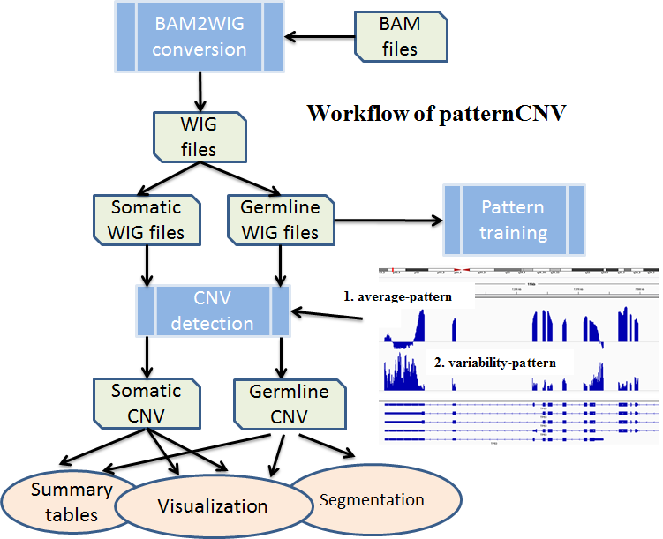

Fig. 1 overall workflow of pattern-CNV.

2. Tool and Package Dependencies

The following Tools and R Packages need to be installed on the user’s system in order for the PatternCNV BAM2WIG and R functions to work:
- SAMtools: http://samtools.sourceforge.net/
- BEDtools: http://bedtools.readthedocs.org
- R: http://www.r-project.org/
  - DNAcopy: http://www.bioconductor.org/packages/2.12/bioc/html/DNAcopy.html
  - fdrtool: http://cran.r-project.org/web/packages/fdrtool/index.html
  - matrixStats: http://cran.r-project.org/web/packages/matrixStats/index.html
  - gplots: http://cran.r-project.org/web/packages/gplots/index.html

3. Required Files

- BAM2WIG conversion
  - BAM files
  - Exon BED file defining the exon regions and gene names
  - Exome Capture Kit BED file defining the regions targeted by the exome capture probes
  - config.txt file containing tool paths
- PatternCNV R functions
  - WIG files from step (1)
  - Exon Key file generated from step (1)
  - config.ini file containing required paths
  - sample_info.txt file containing sample-specific information

3.1 Detailed description of required files
1 (a): BAM files should be either a group of Germline or Tumor/Normal pairs of samples. Files should be coordinate sorted. If duplicate reads are marked then they will be ignored when calculating the coverage.

1 (b): Exon BED file defines the exons or other regions you would like to include in your analysis. The WIG files will contain coverage profiles for these regions. Though not required, it is recommended that gene names be included in the BED file to provide easier interpretation of the CNV results. Example:
chr1 803450 804055 FAM41C
chr1 809491 810535 FAM41C
chr1 812125 812182 FAM41C
chr1 852952 853100 FLJ39609
chr1 853401 853555 FLJ39609
chr1 854204 854295 FLJ39609
chr1 854714 854817 FLJ39609

1 (c): BED file defining the regions targeted by the exome capture probes. This BED file is used to provide annotation that indicates whether or not an exon in the Exon BED file is targeted by a capture probe. The final list of called CNVs will contain this annotation.

1 (d): Config file defining the paths to locally installed tools on the user’s system:
PATTERNCNV=/path/to/PatternCNV
SAMTOOLS=/path/to/samtools-0.1.18/samtools
BEDTOOLS=/path/to/BEDTools/2.15.0/bin

2 (a): WIG file for each of your samples. These files need to be generated using the BAM2WIG code provided in the PatternCNV package.

2 (b): An Exon Key file generated during the BAM2WIG step. This should be the same Exon Key that was used to generate the WIG files. The purpose of this file is to provide additional details about the regions in the WIG files. The Exon Key uses 1-based coordinates. Example:
Chr Start Stop Bin_Count Genes InCapture
chr1 803451 804050 60 FAM41C 0
chr1 809492 810531 104 FAM41C 0
chr1 812126 812175 5 FAM41C 0
chr1 852953 853092 14 FLJ39609 1
chr1 853402 853551 15 FLJ39609 1
chr1 854205 854294 9 FLJ39609 1
chr1 854715 854814 10 FLJ39609 1

2 (c): Config ini file defining paths used by the R functions. These include paths to where the results will be written and paths to the sample info config file along with the Exon Key. Example:
plot_output_DIR = '/path/to/plot_output/'
txt_output_DIR = '/path/to/txt_output/'
exon_key_file = '/path/to/PatternCNV.Exon.Key.txt'
sample_info_file ='/path/to/sample_info.txt'

2 (d): sample_info.txt file containing sample-specific details used by the PatternCNV R functions. This file is tab-delimited with a header, 4 columns, and each sample's information should be on a separate row. The sample.name is a unique sample identifier. The subject.ID is either a unique identifier if all samples are germline or a shared identifier among Tumor/Normal pairs of samples for somatic CNV calling. The sample type can be either "Germline" of "Somatic" (Tumor). The file.name is the full path to the WIG file generated during the BAM2WIG step. Example:
sample.name subject.ID sample.type file.name
X01-Tumor A Somatic /path/to/X01-T.bam.coverage.wig
X01-Normal A Germline /path/to/X01-N.bam.coverage.wig
X02-Tumor B Somatic /path/to/X02-T.bam.coverage.wig
X02-Normal B Germline /path/to/X02-N.bam.coverage.wig

4. Quick example using simulated data

If you would like to quickly try running some of the PatternCNV functions, we have simulated data on our server that can be pointed to from within R. The dataset consists of 12 Germline samples where 2 (c1, c2) contain CNVs. The coverage WIG files and exon key file have already been generated for these samples, so you can skip that step. After downloading the source code from the PatternCNV website, the following R commands can be run:

# load PatternCNV R package
source('Rlib/patCNV.load.package.R',chdir=T)

# load the config file for the simulated data
sim.session_info <- patCNV.load.config('http://bioinformaticstools.mayo.edu/tools/patterncnv/simulated_example/simu.ini')

# scan coverage across samples
germline.covg_info <- patCNV.scan.covg.multi(session_info=sim.session_info)

# examine the coverage of certain genes as a QC check
patCNV.coverage.QC(covg_info=germline.covg_info,session_info=sim.session_info,legend.layout='none',sel_genes=c('BIK','TTLL1'))
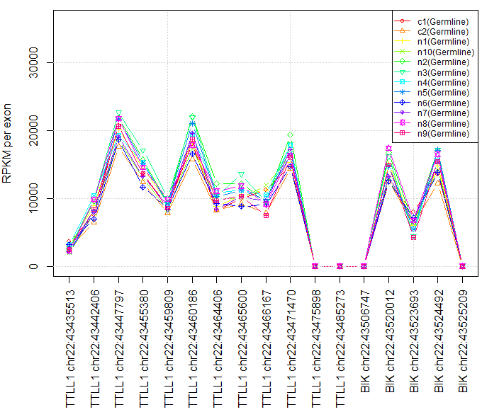

# learn the coverage and variability patterns across samples
patCNV.learn.patterns(session_info=sim.session_info,covg_info=germline.covg_info,sample.type='Germline')

# CNV estimation
germline.cnv_res <- patCNV.compute.CNV.multi(session_info=sim.session_info,sample.type='Germline')

# plot the CNV estimation across a chromosome for a sample
patCNV.plot.Chr.CNV( cnv_res=germline.cnv_res,session_info=sim.session_info,chr_range=c(41e6,44e6),cex=1.2,ylim=c(-3,3),min_ref_avg_RPKM=1,sample_name="c2",sel_chr='chr22')
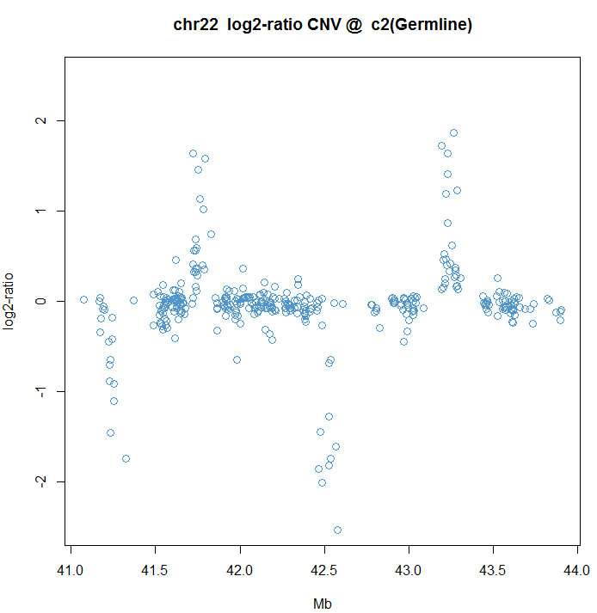

patCNV.plot.Chr.CNV( cnv_res=germline.cnv_res,session_info=sim.session_info,chr_range=c(41e6,44e6),cex=1.2,ylim=c(-3,3),min_ref_avg_RPKM=1,sample_name="n5",sel_chr='chr22')
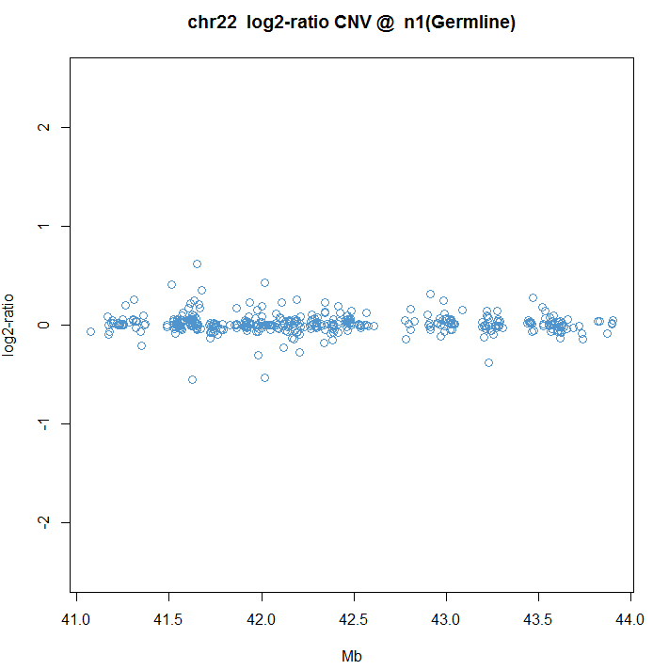

# view the CNV as a heatmap
patCNV.Gene.Heatmap(cnv_res=germline.cnv_res,session_info=sim.session_info,sel_genes=c('NAGA','ARFGAP3','CYB5R3','POLR3H','FAM109B'),Rowv=FALSE)
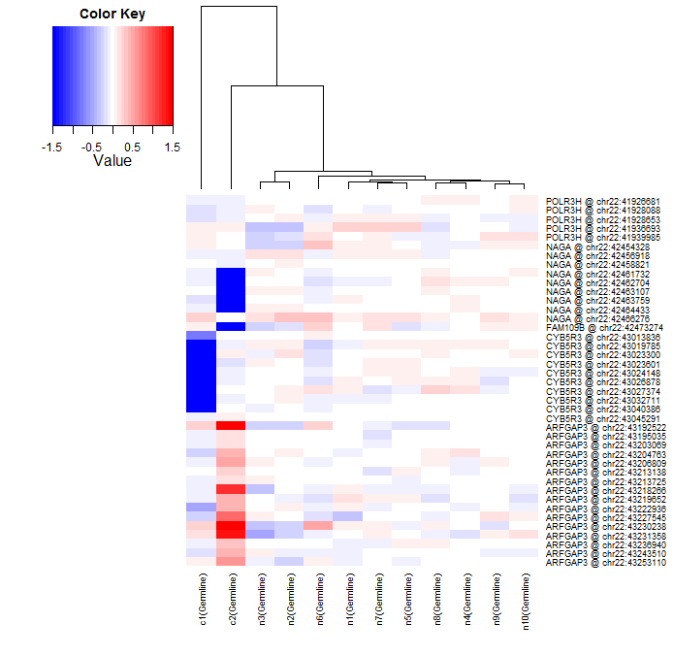

patCNV.Gene.Heatmap(cnv_res=germline.cnv_res,session_info=sim.session_info,sel_genes=c('NAGA','ARFGAP3','CYB5R3','POLR3H','FAM109B'))
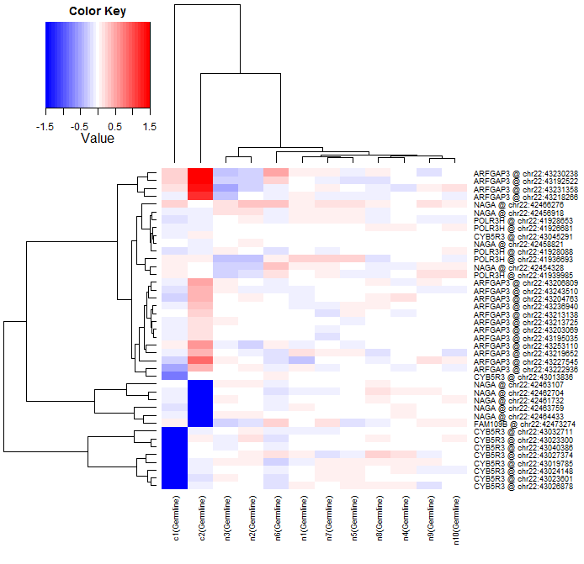

5. Complete walk-through for real data

In this section, we give out a schematic flow of running pattern-CNV R functions for real studies, with Germline-only samples, or Germline-Somatic pairs. Please refer to section 3 of this manual for descriptions of the required input files and config files.

5.1 BAM2WIG

# step 1. Generate an Exon Key file
patterncnv/bam2wig/exon_key.sh /path/to/exons.bed /path/to/capture_kit_targets.bed /path/to/output/Exon.Key.txt 10 /path/to/config.txt

# step 2. Generate a WIG file from BAMs. (Repeat for each BAM)
patterncnv/bam2wig/bam2wig.sh /path/to/sample.sorted.bam /path/to/output_dir/ 10 20 /path/to/config.txt /path/to/output/Exon.Key.txt

5.2 (a) Germline-only study

# step 1. Loading pattern-CNV R functions
source('/path/to/PatternCNV/Rlib/patCNV.load.package.R',chdir=TRUE)

# step 2. Creating a pattern-CNV session from configuration file
test.session_info <- patCNV.load.config('test_config.ini')

# step 3. Summarizing Germline coverage information
germline.covg_info <- patCNV.scan.covg.multi(session_info=test.session_info,sample.type='Germline')

# step 4. Learning average- and variability patterns using Germline samples
patCNV.learn.patterns(session_info=test.session_info, covg_info=germline.covg_info, sample.type='Germline')

# step 5. Calling Germline CNVs
germline.cnv_res <- patCNV.compute.CNV.multi(session_info=test.session_info, sample.type='Germline')

# step 6. Constructing a Null distribution using Germline CNVs
germline.null_model <- patCNV.fit.null.model(session_info=test.session_info, ctrl.cnv_res=germline.cnv_res)

# step 7. Computing nominal p-value, q-value, and local-FDR for called Germline CNVs
germline.FDR_res <-patCNV.estimate.FDR(session_info=test.session_info,cnv_res=germline.cnv_res,null_model=germline.null_model)

# step 8. Exporting exon-level Germline-CNV summary table with specified FDR cut-off (e.g. 1%)
patCNV.export.CNV.tables(session_info=test.session_info, FDR_res=germline.FDR_res,covg_info=germline.covg_info,FDR_threshold=1e-2)

Results:
Upon successful running, you’ll expect exon-level summary tables in <R working directory>/txt_output/, for each Germline sample.

5.2 (b) Somatic study (additional functions beyond Germline-only study)

All the steps in Section 5.2(a) for Germline-only study are required for somatic studies, except for step 7 and 8 if Germline-CNVs are not of interest. In addition, the following functions need to be executed to get somatic CNV results (similar to Germline CNV)

# step 9. Summarizing Germline coverage information
somatic.covg_info <- patCNV.scan.covg.multi(session_info=test.session_info,sample.type='Somatic')

# step 10. Calling Somatic CNVs
somatic.cnv_res <- patCNV.compute.CNV.multi(session_info=test.session_info, sample.type='Somatic')

# step 11. Computing nominal p-value, q-value, and local-FDR for called Germline CNVs
somatic.FDR_res <-patCNV.estimate.FDR(session_info=test.session_info, cnv_res=somatic.cnv_res, null_model=germline.null_model)

# step 12. Exporting exon-level Somatic-CNVs summary table with specified FDR cut-off (e.g. 1%)
patCNV.export.CNV.tables(session_info=test.session_info, FDR_res= somatic.FDR_res, covg_info=somatic.covg_info, FDR_threshold=1e-2)

Similar to Germline-CNV results, you’ll expect exon-level summary tables generated in <R working directory>/txt_output/, for each somatic sample.

5.3 Generate whole-genome and chromosome-level CNV plot

# Plotting autosome CNV results (chr1 to 22)
patCNV.plot.autosome.CNV(session_info=sim.session_info,cnv_res=somatic.cnv, sample_name=<sample.name>)

You’ll expect a plot generated for whole-genome level CNVs, similar to the following figure:

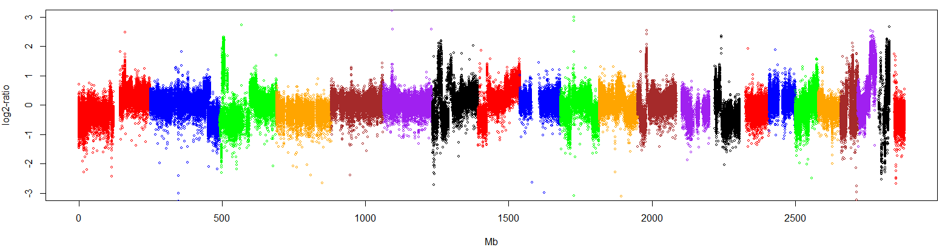
# Plotting selected chromosome (chr12 as an example)
patCNV.plot.Chr.CNV(session_info=sim.session_info,cnv_res=somatic.cnv_res,
sel_chr='chr12',sample_name=<sample.name>)

You’ll see a zoomed-in view of chr12:
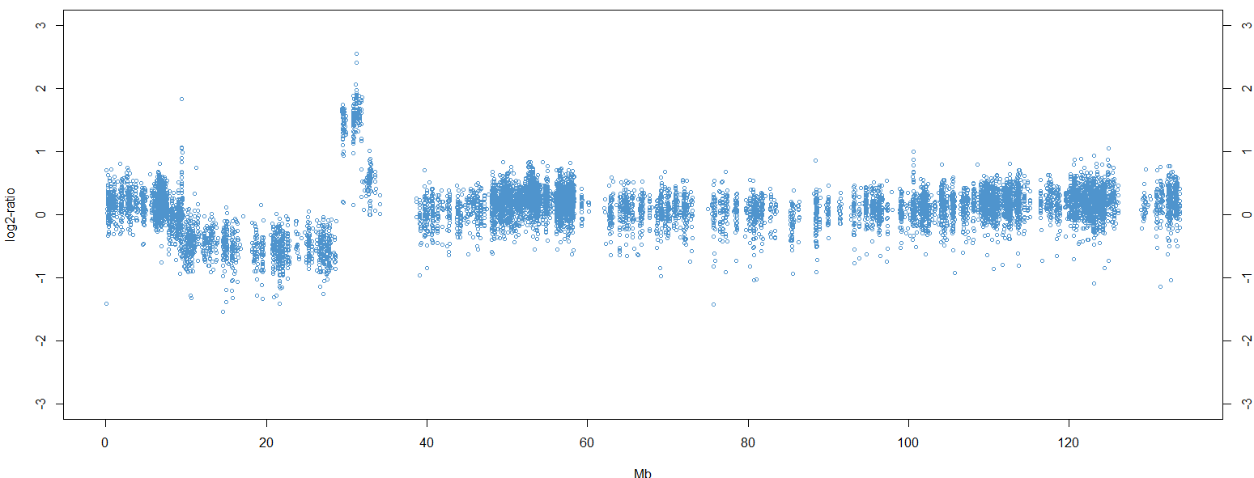

An ideogram can also be added (“SNPchip” R library is required):

# Plotting selected chromosome with ideogram (chr12 as an example)
patCNV.plot.Chr.CNV(session_info=sim.session_info,cnv_res=somatic.cnv_res,
sel_chr='chr12',sample_name=<sample.name>,ideogram=TRUE)

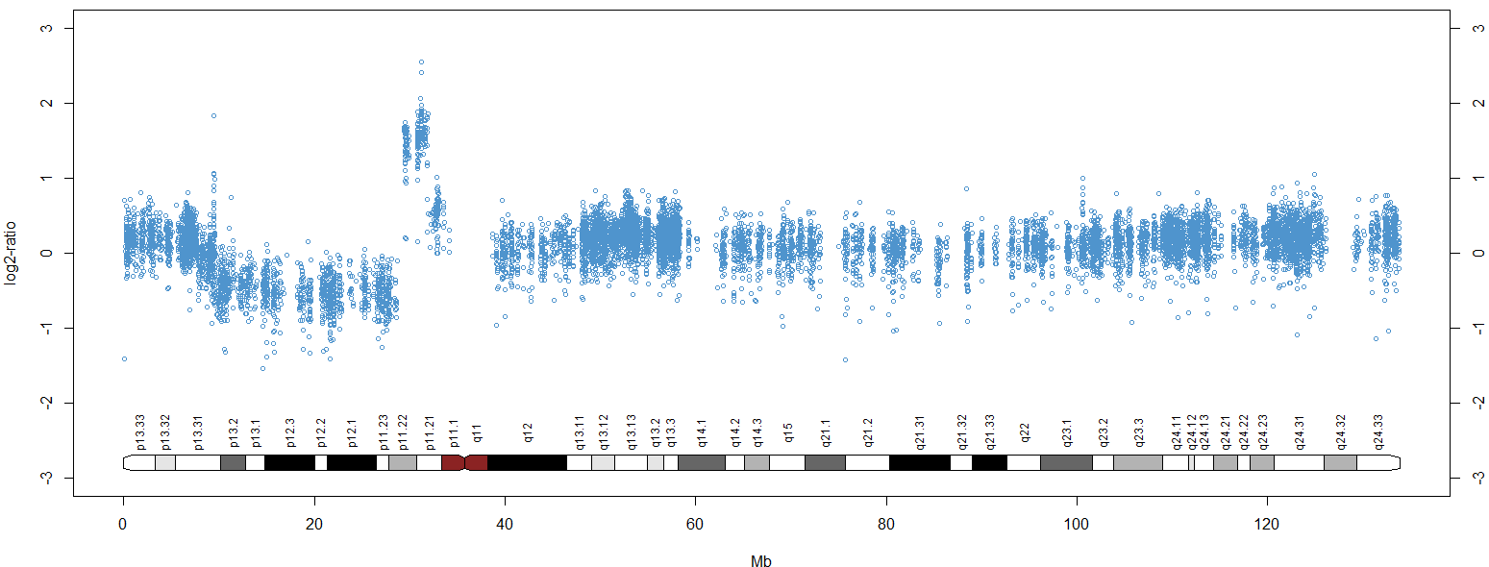
In addition, you can also zoom-in further to a smaller region (chr12: 0-35Mb):

# Plotting selected region of given chromosome with ideogram (chr12: 0Mb-35Mb # as an example), with increased point size (cex option)
patCNV.plot.Chr.CNV(session_info=sim.session_info,cnv_res=somatic.cnv_res,
sel_chr='chr12', sample_name=<sample.name>,ideogram=TRUE, chr_range=c(0,35e6),cex=1.1)

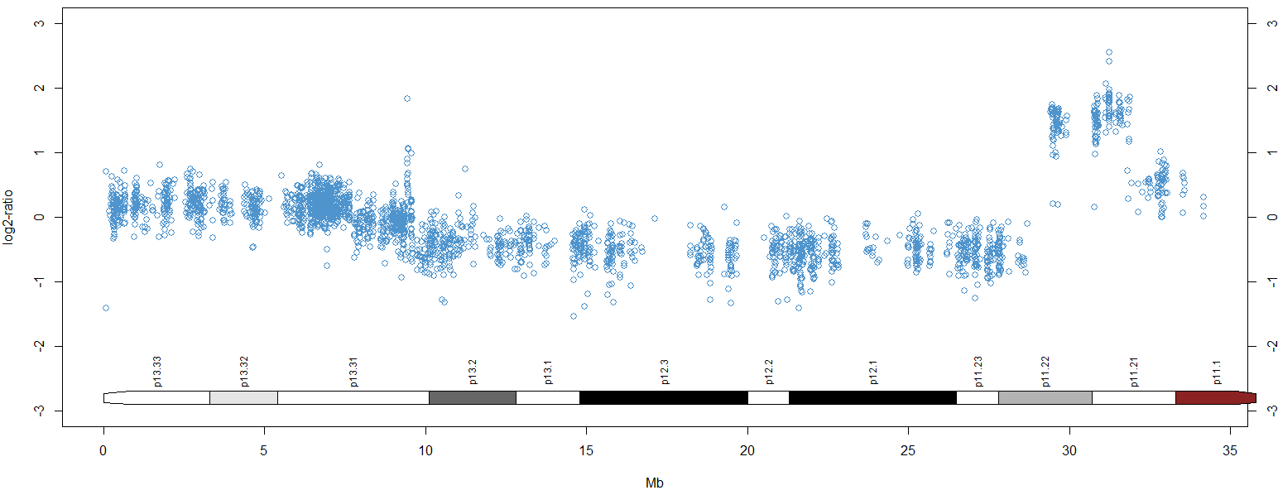

6. BAM2WIG details

For detailed description of the required BED files and config file, please refer to section 3 of this manual.

(a) Generate one ExonKey file for a batch of samples:
USAGE: ./exon_key.sh <exon bed file> <capture kit bed file> <output file> <bin size (10)> <tool config.txt>

Parameter Descriptions:
The <exon bed file> contains the positions of the exons that will be used when generating the coverage WIG file and will be used in the PatternCNV analysis.

The <capture kit bed file> contains the regions targeted by the probes of the capture kit used for your exome samples.

The <output file> is the name of your exon key file that will be generated.

The <bin size (10)> is the size of the bins to use when calculating the coverage across exons. A bin size of 10 is recommended for exome-seq data.

The <tool config.txt> file contains the paths to PatternCNV, SAMtools, and BEDTools.

(b) Generate coverage WIG files for each bam file in your batch of samples:
USAGE: ./bam2wig.sh <input bam file> <output dir> <bin size (10)> <min mapping quality (20)> <tool config.txt> <exon key>

Parameter Descriptions:
The <input bam file> must be coordinate sorted, and preferably duplicate reads have been either been marked or removed.

The <output dir> where the WIG file and temporary files will be written

The <bin size (10)> should match the bin size used when creating the exon key.

The <min mapping quality (20)> is the threshold at which reads will be used for coverage calculation. A minimum mapping quality of 20 is recommended.

The <tool config.txt> file contains the paths to the tools defined above. This is the same file that was used for the exon_key.sh script.

The <exon key> is the path to the Exon Key created in the previous step.

7. R function details

patCNV.load.Rlib {.}
Load specified R-library
Description
This function loads a specified R-library.

Usage
patCNV.load.Rlib ( lib_name, lib_type=c('CRAN','Bioconductor') )

Arguments
lib_name: a character vector containing an R-library name
lib_type: a character vector referring to R-library type: either ‘CRAN’ or ‘Bioconductor’

patCNV.lap.pval {.}
Compute two-sided p-value w.r.t Laplace distribution
Description
This function computes two-sided p-value according to given Laplace distribution.

Usage
patCNV.lap.pval ( q, location = 0, scale = 1 )

Arguments
q: a numeric vector
location: center of Laplace distribution
scale: scale of Laplace distribution

Values
This function returns a numeric vector of two-sided p-values of input numeric vector, w.r.t to given Laplace distribution.

patCNV.load.config {.}
Load configuration file of pattern-CNV
Description
This function loads configuration file defining pattern-CNV session.

Usage
patCNV.load.config (config_file)

Arguments
config_file: a character vector containing configuration filename

Values
This function returns a list of pattern-CNV session information, containing multi components:
exon_info: a list of exon information
file_info: a list of input file information, containing full path to the file, sample name and sample type (e.g. “Germline” and “Somatic”)
DIR_info: a list containing output directory names
pattern: a list containing pattern filenames
Misc: a list containing other related information

patCNV.scan.covg.single {.}
Scan coverage of single sample
Description
This function summarizes exon-level coverage for a single sample. It is not expected to be used by user directly. Instead, this function is usually called by patCNV.scan.covg.multi(.).

Usage
patCNV.scan.covg.single (wig_filename, sample_ID, exon_bin_vec, is_capture_vec,
is.plot=TRUE, log.for.plot=TRUE, plot_output_DIR,
bin_size=10, ylab='# of exons', xlab='log10(coverage per base)')
Arguments
wig_filename: a character vector of wig file name
sample_ID: a character vector of sample ID defined in sample information file
exon_bin_vec: a numeric vector defining number of bins per exon
is_capture_vec: a binary vector specifying if the exon is captured according to design
is.plot: logical value indicating if the coverage summary plot is generated
log.for.plot: logical value indicating if the plot is displayed in log-scale
bin_size: numeric value of exon-level bin-size

Values
This function returns a numeric vector of bp-level coverage per exon.

patCNV.scan.covg.multi {.}
Scan coverage of multi samples
Description
This function summarizes exon-level coverage for multi samples defined by given patternCNV session information.

Usage
patCNV.scan.covg.multi (session_info, sample.type=NULL, bin_size=10, is.verbose=TRUE, is.plot=TRUE)
Arguments
session_info: a list containing current session information of patternCNV. It is returned by patCNV.load.config (.)
sample.type: a character vector of sample type defined in sample information file: e.g. “Germline” or “Somatic”. A value of NULL instructs the function to select all the samples regardless sample types
bin_size: numeric value of exon-level bin-size
is.verbose: logical value indicating if the progress information is printed
is.plot: logical value indicating if the coverage summary plot is generated

Values
This function returns a list of multi-sample coverage information, containing multi components:
total_count_vec: a numeric vector containing total bp-level coverage per sample
exon_count_mtx: a numeric matrix (exon by sample) containing bp-level exon coverage
exon_RPKM_mtx: a numeric matrix (exon by sample) containing normalized exon coverage

patCNV.coverage.QC {.}
Produce coverage plot to facilitate quality-check with given genes
Description
This function displays coverage plot for given genes, to facilitate quality-check.

Usage
patCNV.coverage.QC (session_info, covg_info, sel_genes, legend.layout="topleft",
legend.cex=0.5)

Arguments
session_info: a list containing current session information of patternCNV. It is returned by patCNV.load.config (.)
covg_info: a list containing coverage information. It is returned by patCNV.scan.covg.multi(.)

sel_genes: a character vector of genes of interest
legend.layout: a character vector of legend location. It should be "bottomright", "bottom", "bottomleft", "left", "topleft", "top", "topright", "right", "center" or "none". When "none" is used, no legend will be plotted for clarity.
legend.cex: legend character expansion factor relative to current par("cex")

patCNV.chr.coverage.QC {.}
Produce coverage plot to facilitate quality-check across chromosomes
Description
This function displays coverage plot for chromosome 1-22, to facilitate quality-check.

Usage
patCNV.chr.coverage.QC (session_info, covg_info, legend.layout="topright")

Arguments
session_info: a list containing current session information of patternCNV. It is returned by patCNV.load.config (.)
covg_info: a list containing coverage information. It is returned by patCNV.scan.covg.multi(.)
legend.layout: a character vector of legend location. It should be "bottomright", "bottom", "bottomleft", "left", "topleft", "top", "topright", "right", "center" or "none". When "none" is used, no legend will be plotted for clarity.

patCNV.learn.patterns {.}
Learn average and variability patterns
Description
Learn patterns from normal samples
Usage
patCNV.learn.patterns (session_info, covg_info,
sample.type=NULL, episl=1, bin_size=10,
exclude_sample_name = NULL )
Arguments
session_info: a list containing current session information of patternCNV. It is returned by patCNV.load.config (.)
covg_info: a list containing coverage information. It is returned by patCNV.scan.covg.multi(.).
sample.type: a character vector of sample type defined in sample information file: e.g. “Germline”. A value of NULL instructs the function to select all the samples regardless sample types
episl: a small value adding to coverage to avoid doing log-transform on zero
bin_size: numeric value of exon-level bin-size
exclude_sample_name:
a character vector containing sample names that are excluded for pattern training

patCNV.compute.CNV.single{.}
Compute copy number variation (CNV) for single sample
Description
This function computes exon-level copy number variations for a given single sample.

Usage
patCNV.compute.CNV.single (session_info, sample_name, episl=1, bin_size=10,
is.verbose=TRUE)
Arguments
session_info: a list containing current session information of patternCNV. It is returned by patCNV.load.config (.)
sample_name: a character vector of sample name defined in sample information file
episl: a small value adding to coverage to avoid doing log-transform on zero
bin_size: numeric value of exon-level bin-size
is.verbose: logical value indicating if the progress information is printed

Values
This function returns a list of single-sample CNV information, containing multi components:
CNV: a numeric vector containing exon-level log2-ratio CNV signals
sample.ID: a character of sample ID
sample.name: a character of sample name

patCNV.compute.CNV.multi{.}
Compute copy number variation (CNV) for multiple samples
Description
This function computes exon-level copy number variations for multiple samples.

Usage
patCNV.compute.CNV.multi ( session_info, sample.type=NULL,
episl=1, bin_size=10, is.verbose=FALSE)
Arguments
session_info: a list containing current session information of patternCNV. It is returned by patCNV.load.config (.)
sample.type: a character vector of sample type defined in sample information file: e.g. “Germline”. A value of NULL instructs the function to select all the samples regardless sample types
episl: a small value adding to coverage to avoid doing log-transform on zero
bin_size: numeric value of exon-level bin-size
is.verbose: logical value indicating if the progress information is printed

Values
This function returns a list of multi-sample CNV information, containing multi components:
CNV: a numeric matrix (exon by sample) exon-level log2-ratio CNV signals
sample.ID: a character vector containing multiple sample IDs
sample.name: a character vector containing multiple sample names

patCNV.fit.null.model{.}
Fit Null distribution of copy number variation signals
Description
This function fits null distribution of copy number variation signals.

Usage
patCNV.fit.null.model (session_info, ctrl.cnv_res, type='autosome', is.plot=FALSE)
Arguments
session_info: a list containing current session information of patternCNV. It is returned by patCNV.load.config (.)
ctrl.cnv_res: a list of CNV results from control samples, where very few CNVs are expected. It is usually returned by patCNV.compute.CNV.multi (.), with sample.type=“Germline”
type: a character of either “autosome” or “all” to indicate if CNV signals of chr1-22 or all of the chromosomes are used for fitting Null distribution
is.plot: logical value indicating if the null distribution is plotted

Values
This function returns a list of null distribution model that is used by patCNV.estimate.FDR(.)

patCNV.estimate.FDR{.}
Estimate false positive rate of copy number variation signals
Description
This function estimates false positive rate (FDR) of copy number variation signals.

Usage
patCNV.estimate.FDR( session_info, cnv_res, null_model, is.plot=FALSE )

Arguments
session_info: a list containing current session information of patternCNV. It is returned by patCNV.load.config (.)
cnv_res: a list of CNV returned by patCNV.compute.CNV.multi (.)
null_model: a list returned by patCNV.fit.null.model (.)
is.plot: logical value indicating if the FDR distribution is plotted

Values
This function returns a list of multi-sample CNV information and estimated statistical significance, containing multi components:
CNV: a numeric matrix (exon by sample) exon-level log2-ratio CNV signals
sample.ID: a character vector containing multiple sample IDs
sample.name: a character vector containing multiple sample names
rawp.mtx: a numeric matrix (exon by sample) of exon-level un-corrected p-values
qval.mtx: a numeric matrix (exon by sample) of exon-level corrected q-values
LFDR.mtx: a numeric matrix (exon by sample) of exon-level corrected local-FDRs

patCNV.export.CNV.tables{.}
Exports exon-level CNV information as per-sample tables
Description
This function exports estimated exon-level CNV information as per-sample tables, with given statistical significance cut-off.

Usage
patCNV.export.CNV.tables (session_info, covg_info, FDR_res, ref_avg_type='median',
min_ref_avg_RPKM=3, output_suffix='_CNV_table.txt',
capture.only=TRUE, FDR_type='localFDR', FDR_threshold=1e-3)
Arguments
session_info: a list containing current session information of patternCNV. It is returned by patCNV.load.config (.)
covg_info: a list containing coverage information. It is returned by patCNV.scan.covg.multi(.).
FDR_res: a list of CNV and estimated statistical significance returned by patCNV.estimate.FDR (.)
ref_avg_type: a character indicating if exon-level “median” or “mean” coverage information should be outputted in the table
min_ref_avg_RPKM: minimum normalized coverage of output exons
output_suffix: a character of filename suffix of per-sample summary table
capture.only: a logical value indicating if only captured exons should be outputted
FDR_type: whether “localFDR” or “qvalue” is considered as statistical criterion
FDR_threshold: only exon with “localFDR” or “qvalue” below the threshold will be outputted

patCNV.plot.Chr.CNV{.}
Generate chromosome-level CNV plot of given sample
Description
This function generates chromosome-level CNV plot (log2-ratio) of given sample.

Usage
patCNV.plot.Chr.CNV( session_info, cnv_res, sample_name, sel_chr='chr1', chr_range=NULL,
capture.only=TRUE, min_ref_avg_RPKM=3,ref_avg_type='median',
cex=0.65,col='steelblue3',ylim=c(-3,3))
Arguments
session_info: a list containing current session information of patternCNV. It is returned by patCNV.load.config (.)
cnv_res: a list of CNV returned by patCNV.compute.CNV.multi (.)
sample_name: a character of sample name of interest
sel_chr: a character of chromosome to be plotted
chr_range: a numeric vector specifying the range of chromosome (start: chr_range[1]; end: chr_range[2] )
capture.only: a logical value indicating if only captured exons should be outputted
min_ref_avg_RPKM: minimum normalized coverage of output exons
ref_avg_type: a character indicating if exon-level “median” or “mean” coverage information should be considered
cex: character (or symbol) expansion: a numerical vector
col: a character specifying color used for plotting
ylim: a numeric vectors specifying range of y-axis

patCNV.plot.autosome.CNV{.}
Generate autosome (chr1-22) CNV plot of given sample
Description
This function generates autosome CNV plot (log2-ratio) of given sample.

Usage
patCNV.plot.autosome.CNV (session_info, cnv_res, sample_name, chr_ver='hg19',
capture.only=TRUE, min_ref_avg_RPKM=3, ref_avg_type='median',
ylim=c(-3,3),cex=0.6,
color_vec=c('red','blue','green','orange','brown','purple','black'))
Arguments
session_info: a list containing current session information of patternCNV. It is returned by patCNV.load.config (.)
cnv_res: a list of CNV returned by patCNV.compute.CNV.multi (.)
sample_name: a character of sample name of interest 'hg19' or 'hg18'
chr_ver: a character vectors of chromosome version:
capture.only: a logical value indicating if only captured exons should be outputted
min_ref_avg_RPKM: minimum normalized coverage of output exons
ref_avg_type: a character indicating if exon-level “median” or “mean” coverage information should be considered
ylim: a numeric vectors specifying range of y-axis
cex: character (or symbol) expansion: a numerical vector
color_vec: a character vectors specifying colors used for plotting autosome CNVs

patCNV.Gene.Heatmap{.}
Generate CNV heatmap of given genes
Description
This function generates CNV heatmap of given genes across multiple samples.

Usage
patCNV.Gene.Heatmap ( session_info, cnv_res, sel_genes, ref_avg_type='median',
min_ref_avg_RPKM=3, capture.only=TRUE, font.cex=0.7)
Arguments
session_info: a list containing current session information of patternCNV. It is returned by patCNV.load.config (.)
cnv_res: a list of CNV results returned by patCNV.compute.CNV.multi (.)
sel_genes: a character vector of genes of interest
ref_avg_type: a character indicating if exon-level “median” or “mean” coverage information should be considered
min_ref_avg_RPKM: minimum normalized coverage of output exons
capture.only: a logical value indicating if only captured exons should be outputted
font.cex: character (or symbol) expansion for font size: a numerical vector

patCNV.segment.CNV{.}
Output CNV segmentation results
Description
This function outputs CNV segmentation results across multiple samples.

Usage
patCNV.segment.CNV( session_info, cnv_res, capture.only=TRUE, ref_avg_type='median',
min_ref_avg_RPKM=3, is.plot=TRUE, plot.ylim=c(-3,3),
plot.cex=0.6,output_suffix='CNV_seg')

Arguments
session_info: a list containing current session information of patternCNV. It is returned by patCNV.load.config (.)
cnv_res: a list of CNV results returned by patCNV.compute.CNV.multi (.)
ref_avg_type: a character indicating if exon-level “median” or “mean” coverage information should be considered
min_ref_avg_RPKM: minimum normalized coverage of output exons
is.plot: logical value indicating if the FDR distribution is plotted
plot.ylim: a numeric vectors specifying range of y-axis
plot.cex: character (or symbol) expansion for point size
output_suffix: a character of filename suffix of per-sample CNV segmentation results

